Psalm 32 - Organ.tif

Psalm 121 - Organ.tif

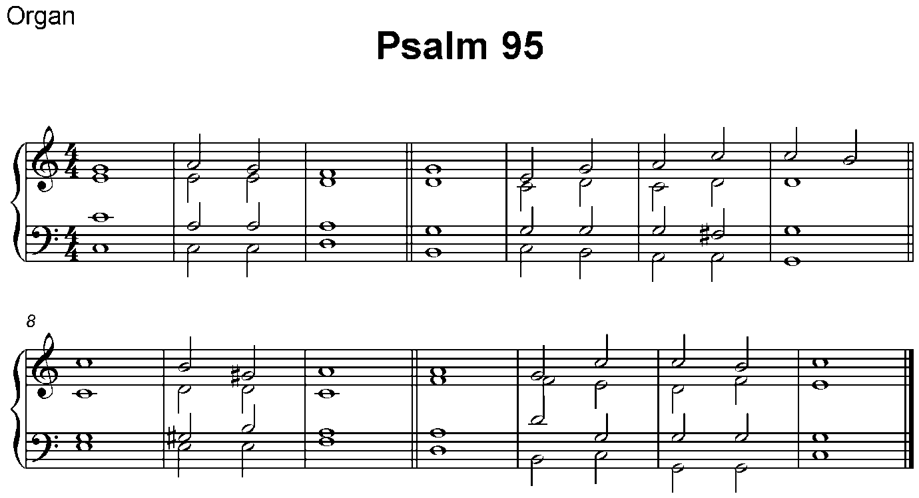



**Psalm 95**

1. O come, let us | sing to the | Lord;

let us heartily rejoice in the | rock of | our sal- | vation.

2, Let us come into his | presence with | thanksgiving

and be | glad in | him with | psalms.

3. For the Lord is a | gre-at | God

and a great | king a- | bove all | gods.

4. In his hands are the |depths of the | earth

and the heights of the | mountains are | his | also

*2nd part of chant*

5 The sea is his, | for he | made it,

and his hands have | moulded the | dry | land.

6. Come, let us worship and | bow | down

and kneel be- |fore the | Lord our | Maker.

7. For | he is our | God;

we are the people of his | pasture and the | sheep of his | hand.

8. O today that you would | listen to his | voice;

Harden not your hearts as at Meribah, on that day at | Mas-sah | in the wilderness,

9. When your forbears tested me, and | put me to the | proof

though | they had | seen my | works.

10. Forty years long I detested that gene- | ration and | said,

"These people are wayward in their hearts; they | do not | know my | ways."

11. So I | swore in my | wrath,

"They shall not | en-ter | into my | rest."

Glory to the Father and | to the | Son

and | to the | Ho-ly | Spirit;

as it was in the be-|ginning is | now

and shall be for |ev-er. |A- | men.

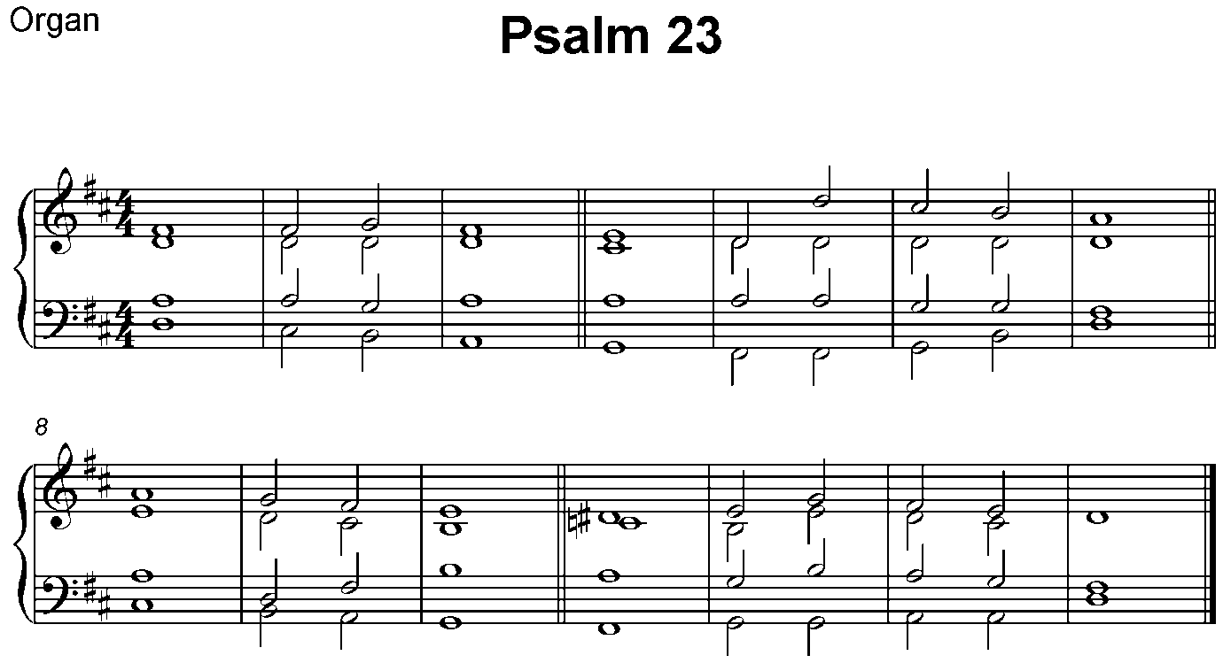





***Ready for Sunday sheet for Lent 4, year A:***

**Psalm** **23**

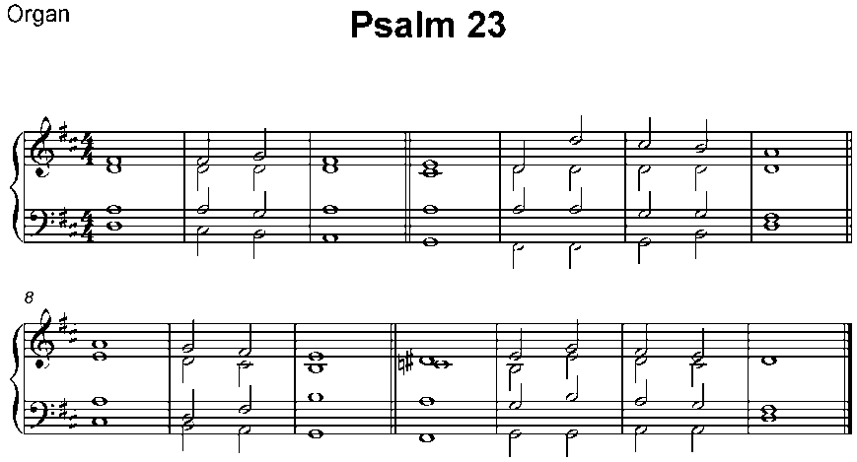

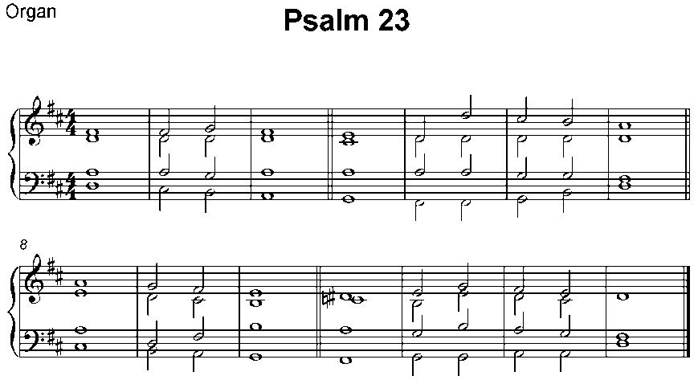

1. The Lord | is my | shepherd;

therefore | can I | la-ck | nothing.

2. He makes me lie down in |gre-en | pastures

and leads me be-| si-de | sti-ll | waters.

3. He shall re- | fresh my | soul

and guide me in the paths of righteousness | for his | name's |sake.

4. Though I walk through the valley of the shadow of death, I will | fear no | evil;

for you are with me; your | rod and your | staff, they | comfort me.

5. You spread a table before me in the presence of | those who | trouble me;

you have anointed my head with oil | and my | cup shall be | full.

6. Surely goodness and loving mercy shall follow me all the | days of my | life,

and I will dwell in the | house of the |Lord for | ever.

Glory to the Father and | to the | Son

and | to the | Ho-ly | Spirit;

as it was in the be-| ginning is | now

and shall be for | e-ver | A- | men.

**Psalm 127. 1-4 *(check before use) – for Mothering Sunday, option 2***

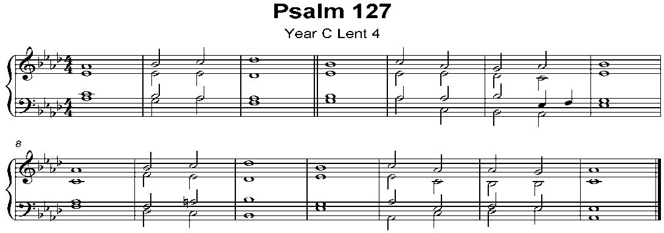

1 Unless the Lord | builds the | house,

those who | build it | labour in | vain.

2 Unless the Lord | keeps the | city,

the | guard keeps | watch in | vain.

3 It is in vain that you hasten to rise up early and go so late to rest,

eating the | bread of | toil,

for he | gives his be- | lov-ed | sleep.

4 Children are a heritage | from the | Lord

and the fruit of the | womb | is his | gift.

Glory to the Father and | to the | Son

and | to the | Ho-ly | Spirit;

as it was in the be-| ginning is | now

and shall be for | e-ver | A- | men.

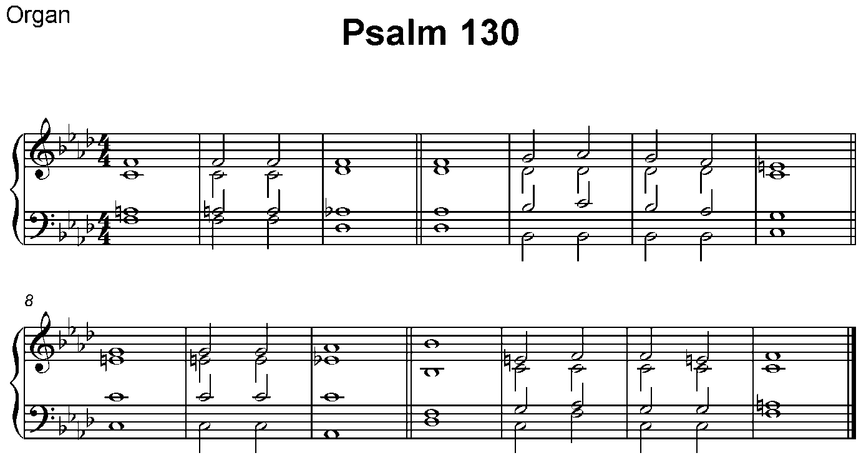









1. Out of the depths have I cried to you, O Lord; Lord | hear my | voice;

let your ears consider well the | voice of my | sup -pli- | cation.

2. If you, Lord, were to mark what is | done a- | miss,

O | Lord, | who could | stand?

*2nd part of chant*

3. But there is for- | giveness with | you,

so | that you | shall be | feared.

4. I wait for the Lord; my | soul | waits for him;

in his | word |is my | hope.

5. My soul waits for the Lord, more than the night watch | for the | morning.

more than the | night watch | for the | morning.

6. O Israel, | wait for the | Lord,

for with the | Lord | there is | mercy;

7. With him is | plenteous re- | demption

and he shall redeem | Israel from | all their | sins.

Glory to the Father and | to the | Son

and | to the | Ho-ly | Spirit;

as it was in the be-|ginning is | now

and shall be for |ev-er. |A- | men.